ML Algorithms

SoftMax Logistic Regression:
How does it work (intuitive):
Will take a dataset with three class:
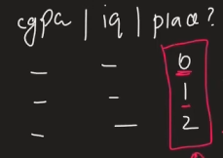
Apply one-hot encoding to it:
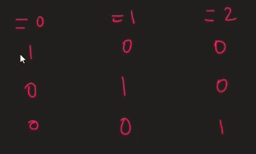
Now we will make three datasets differently like:
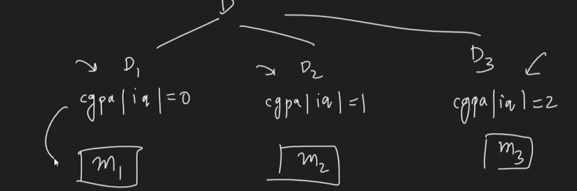
M1 M2 and M3 are three different model will be applied with Logistic Regression separately (we will change this step as will be hard to do for large datasets)

Each model will give us 3 coef:

Now at the prediction stage: 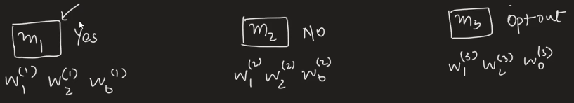
If we take a input for prediction like
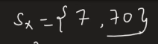
Then,
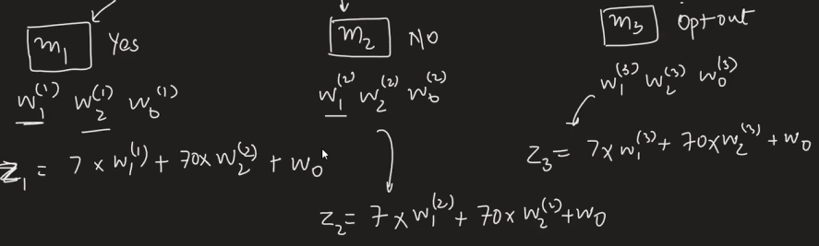
Calculating SoftMax for each of the z values,
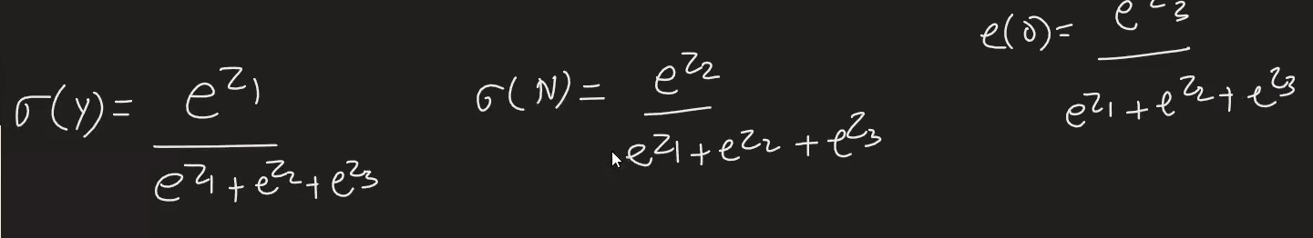

We get three values:0.40, 0.35, 0.25
Value of sigmoid(y) is more than others therefore placement is yes

This is just the process now will look how sklearn library works with Loss Function
Loss function in case of LGR:
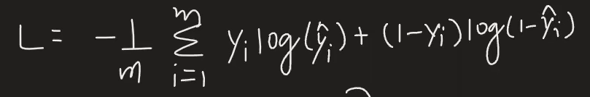

We update it in for SoftMax:
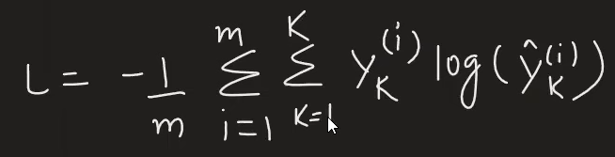
Understanding this with Example:

Taking a dataset with three class and doing one-hot encoding on it
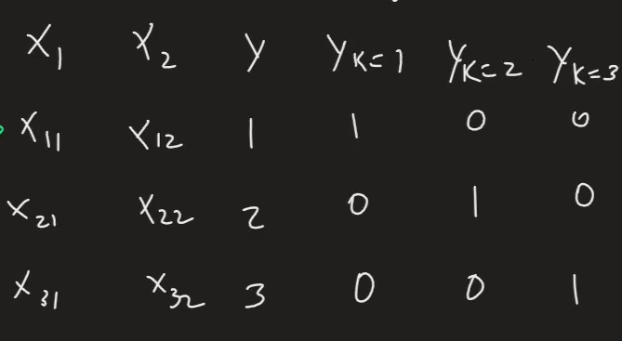
K is class and i is rows: in this case we have three rows
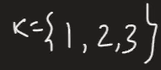
Expansion of loss function comes out to be:
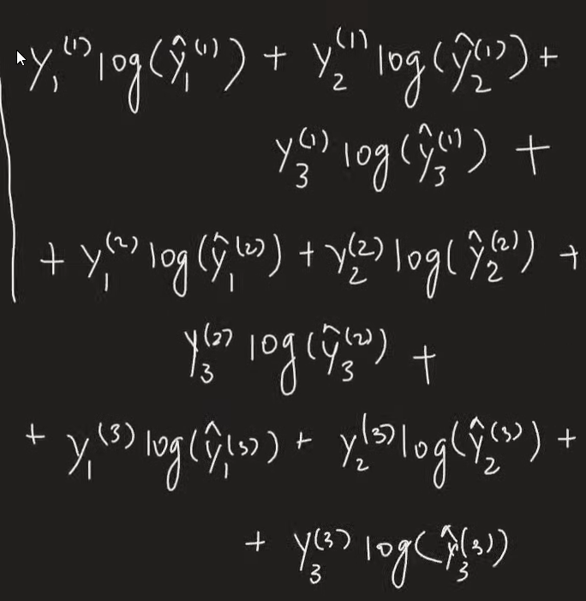
After simplifying:
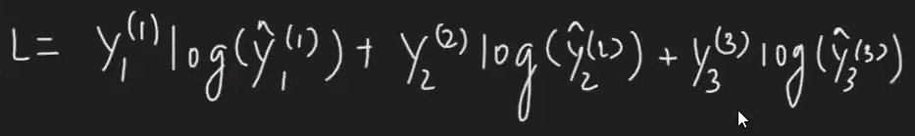
Y hat values from the equation using SoftMax:
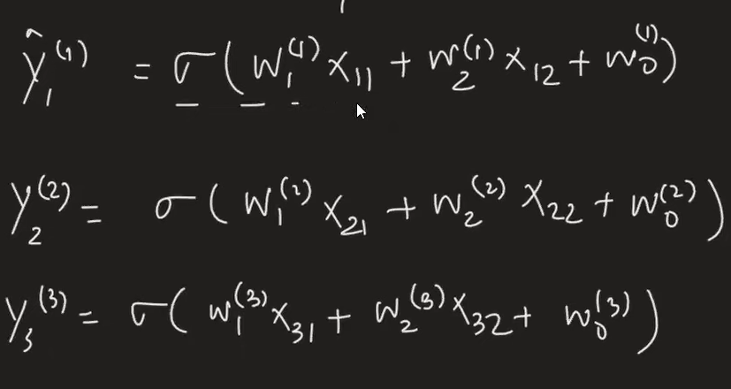

We are getting 9 diff weights as its visible above,
While performing gradient descent we need to apply derivative with respect to each of weight
And update function for each of the weight till we find best weight value

